Assignment – 1

* **Making a basic computer connection.**

Step 1 : Take 2 PCs and 1 Switch (or 2 Routers for advanced setups).

Step 2 : Connect devices using Straight-Through cables (PC to Switch) or

Cross-Over cables (Router to Router).

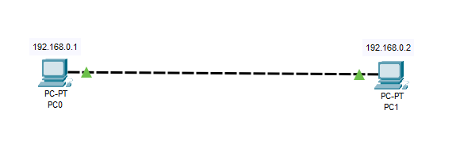

Step 3 : Assign IP Address, Subnet Mask, and Default Gateway to each PC:

Step 3.1 : Open PC → Desktop → IP Configuration → Enter ⏎

Step 3.2 : IP : 192.168.0.1 (PC-0), 192.168.0.2 (PC-1)

Step 3.3 : Subnet Mask: 255.255.255.0

Step 3.4 : Leave gateway empty for same-network PCs or add

router IP.

Step 4 : Test the Network Connection.

Step 4.1 : Open PC-0’s Command Prompt → Type :

ping 192.168.0.2 → which is PC-1’s IP

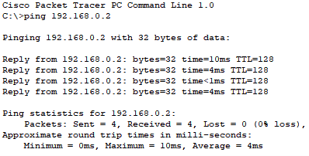

Step 5 : Replies are successful, the connection works!